**Project Overview**

The web site is *Online Student Survival Guide.* The purpose of the site is to provide tools beyond the typical advice given to college students; being told to “stay motivated” and “don’t procrastinate” are great pieces of advice but are seldom backed up with practical ways to tackle the day-to-day challenges of taking a class online. The target audience is an average student in higher education; one who has multiple competing priorities in their life. The target audience is not a straight ‘A’ student, and the title of the web site purposely does not mention grades.

Content Pages:

* + Home (Index)
  + About Us
  + First Day
  + Uses of a Smartphone
  + Failure is Always an Option

Home/Index

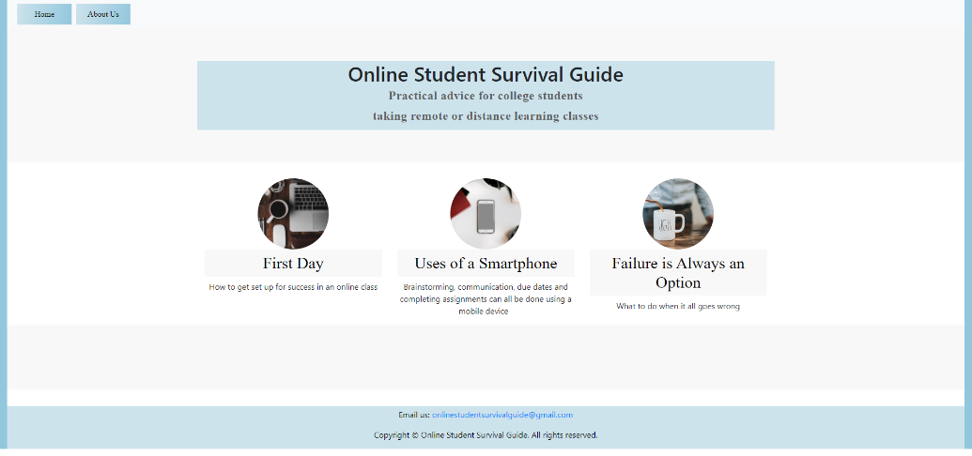

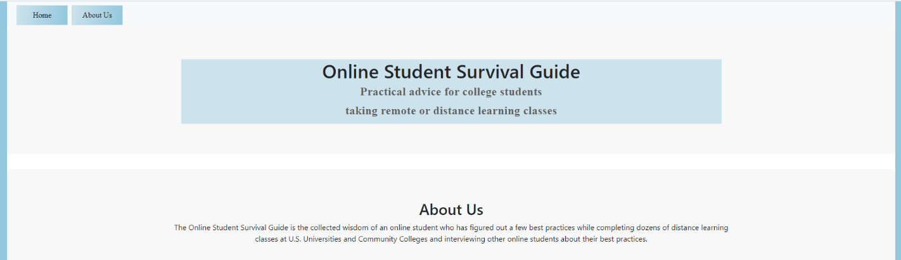About Us

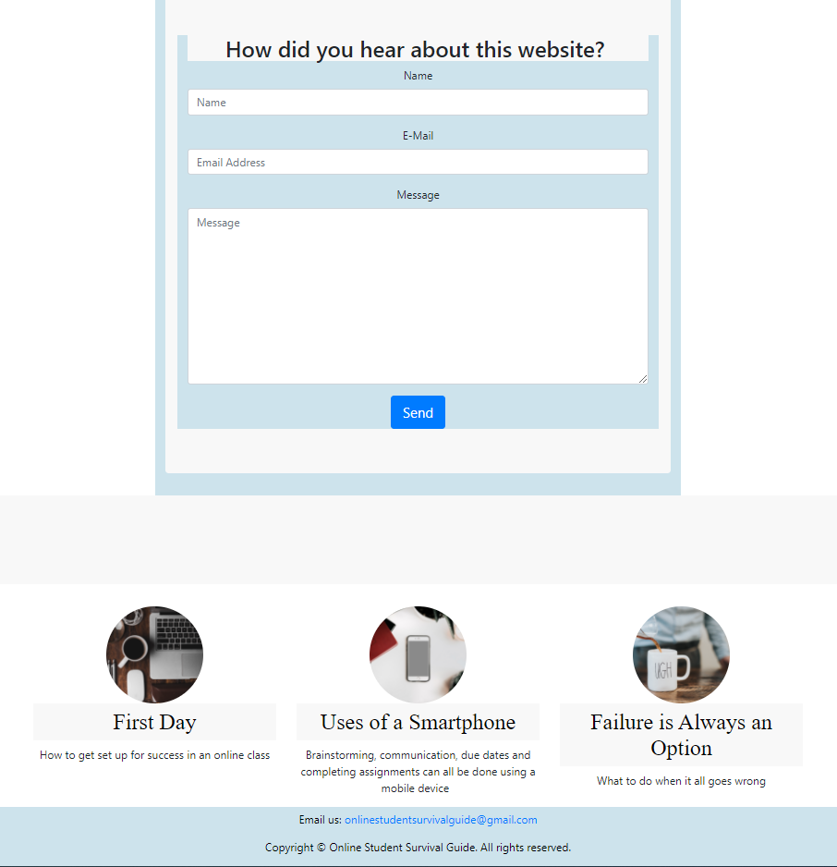

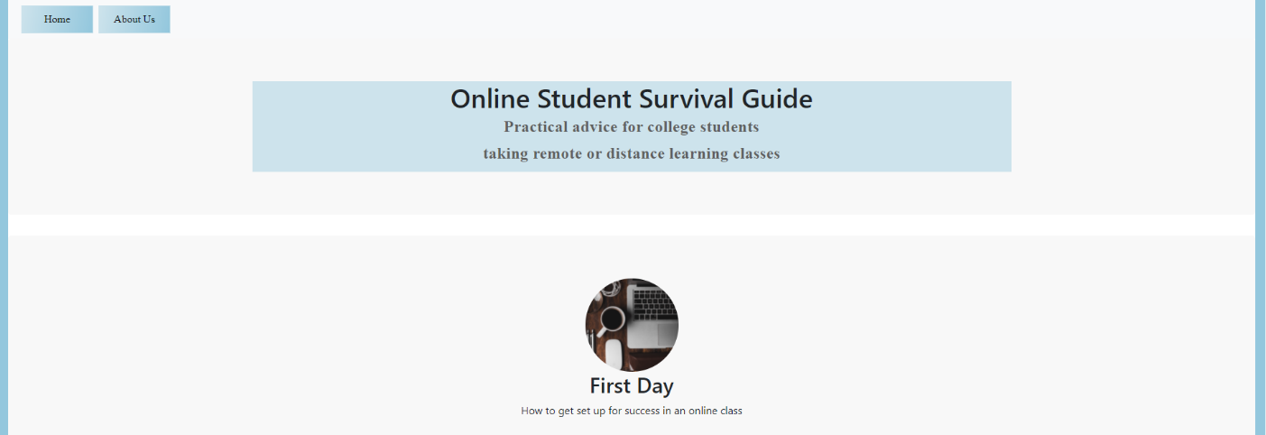First Day

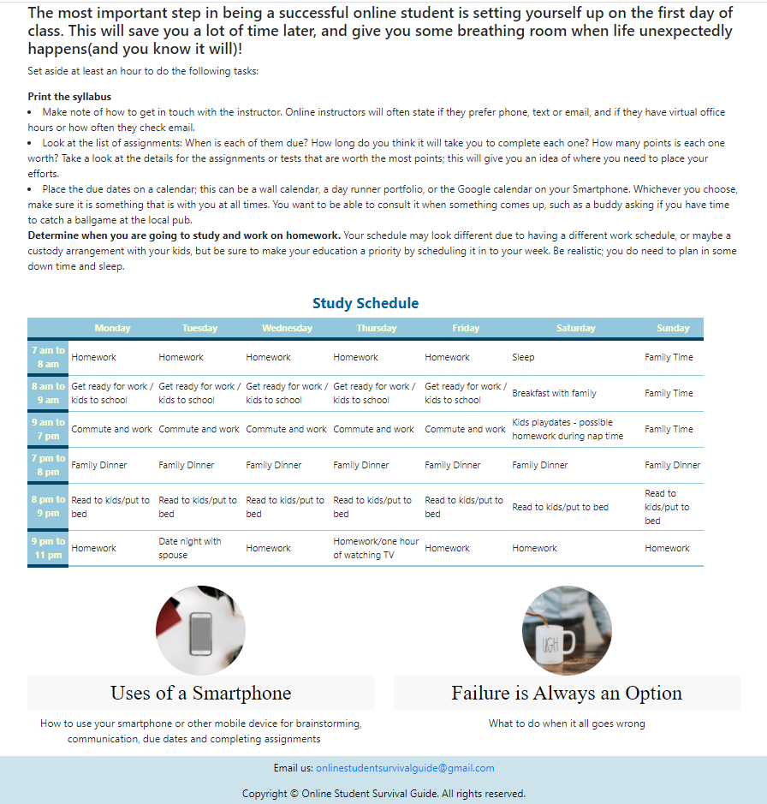

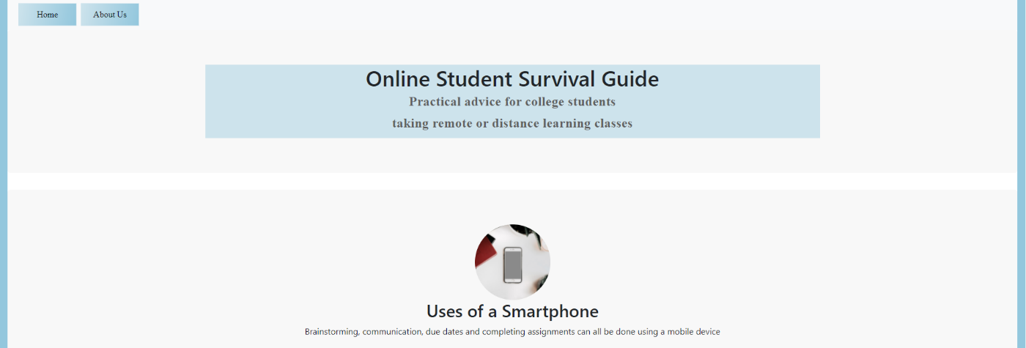Uses of a SmartPhone

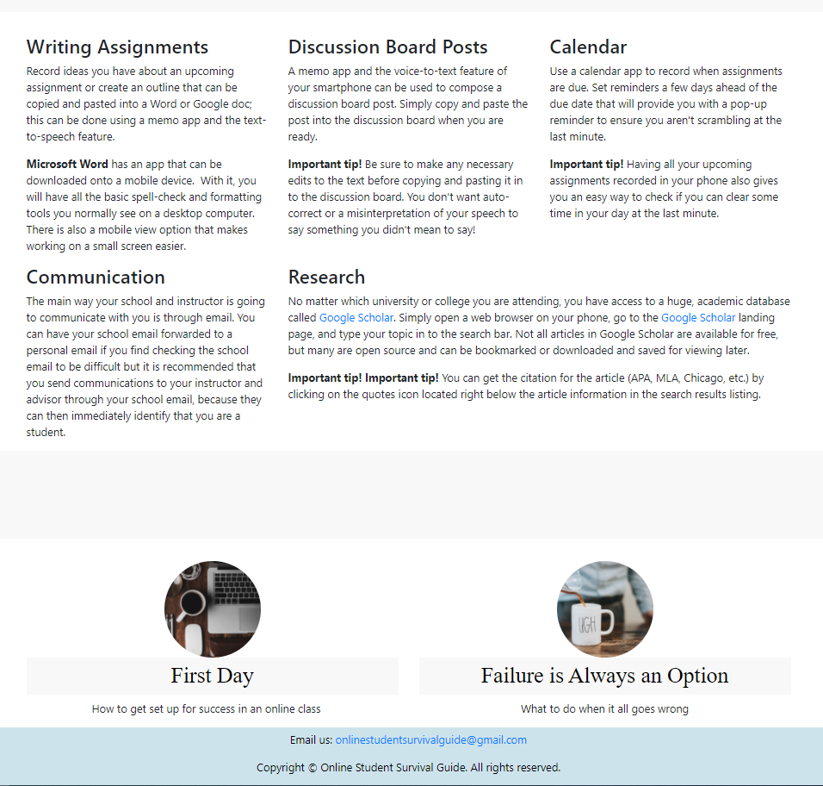

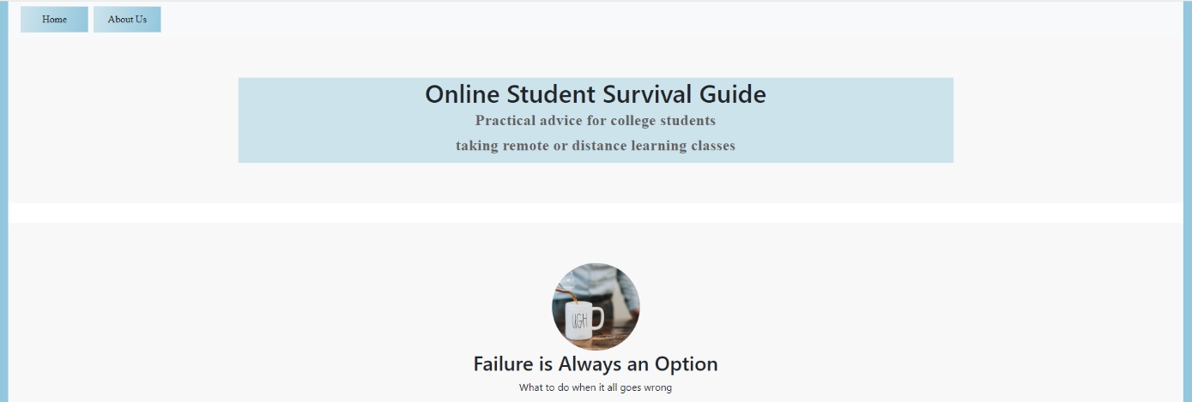Failure is Always an Option

